Processing microtome slides with GIMP and ImageJ

Roman M. Link

April 2020

# Introduction

This is a simplified short form of the BOT2 [tutorial](https://github.com/r-link/microtome_slides) for the pre-processing and analysis of wood anatomical microtome slides based on [GIMP](https://www.gimp.org/) and [ImageJ](https://imagej.nih.gov/ij/) which is meant for in-class use.

A list of useful GIMP shortcuts can be found here: (<https://www.gimpusers.com/gimp/hotkeys>).

Note that the term CODE in this document is a placeholder that has to be replaced by the unique ID of sample you are working with! In the screenshots in this example, the CODE is CRI_3_010.

# Important note

All ImageJ results tables can be saved either in ‘Comma Separated Value’ (.csv) or whitespace/tabstop separated format (generated when saving with a .xls extension, but actually just a plain text format). In either case, the output is optimized for US/UK locales, which means that points are used as a decimal separator. In order to process these files on German systems without compatibility issues, it is important to make sure that the system-wide decimal separator is correctly set before starting the analysis.

In German Windows 10, the option to change the decimal separator is well hidden:

**Start Menu ➜ Windows-System ➜ Systemsteuerung ➜ Zeit und Region ➜ Region ➜ Formate ➜ Weitere Einstellungen ➜ Dezimaltrennzeichen**

To avoid data compatibility problems, make sure the decimal separator is set to “.”. In this case, you will want the grouping symbol (**Symbol für Zifferngruppierung**) to be a comma instead of the point symbol used in Germany.

If you do not want to change your system settings, you can alternatively export everything in a .csv format and use Excel’s **Daten ➜ Text in Spalten** menu to manually set field delimitor and decimal separator.

**It is generally recommended to create a separate folder for each sample and to keep all files belonging to the sample in this folder. Folders should always be named by sample ID.**

# Preparation in GIMP

1. Open original image CODE.jpg



1. Cut out a wedge of the original image with the Polygon Lasso tool (GIMP shortcut: *F*)
   * Select a wedge of the original picture
     + select a representative section of the sample (i.e., avoid tension and compression wood),
     + trace the ray parenchyma to avoid including incomplete vessels,
     + a subsample of around 300-500 vessels is sufficient, but 1000+ is preferable.
   * In older versions of GIMP, a double click ends the selection process. In the current version, you have to press *Enter* instead.
   * Copy selection (*Ctrl + C*),
   * Paste selection to new file (*Ctrl + Shift + V*). Use the shortcut instead of creating a new file manually - this way the image will be automatically cropped, which saves computing power.



1. Save the file CODE_GI_cropped_01.jpg (using the “Export as” option or via *Ctrl + Shift + E*).
2. Close tab with original image (do *not* save changes!)
3. [optionally] adjust brightness and contrast using color curves (German: **Farben ➜ Kurven**, English: **Colors ➜ Curves**)
   * move the lower point close to the left end of the histogram to make sure the darkest portions of the image are actually black.



1. If your sample is surrounded by transparency (indicated by a checkerboard pattern) instead of a white background:
   * make sure the background color is set to white (Press *D* to switch to the standard foreground/background colors),
   * right click on the layer in the layer menu (usually bottom right) and remove the alpha channel (**Alphakanal entfernen**),
   * now the image should be surrounded by a white background.
2. Decompose the image into its RGB components (German: **Farben ➜ Komponenten ➜ Zerlegen**, English: **Colors ➜ Components ➜ Decompose**) - this creates a new image that separates the original image into its red, green and blue channel (if this step changes the shape of the wood section and suddenly cut-out areas reappear, you forgot to delete the alpha channel).



1. Hide all layers except the green layer by clicking on the eye symbol in the *Layers* panel, then export (*Ctrl + Shift + E*) the new image as CODE_GI_cropped_02.jpg.



1. Close the tab with the black and white image.

# Analysis in ImageJ

1. open ImageJ.
   * **IMPORTANT:** make sure that the options for analyzing threshold images are correctly set. Go to **Process ➜ Binary ➜ Options** and make sure that the box **Black background** is not marked to avoid problems with the particle analysis macro.



1. open the original image with the scale bar (CODE.jpg) with ImageJ (either by the File dialog or by dragging and dropping onto the ImageJ window).
   * Make sure the image is set to grayscale (i.e. 8bit color space) by verifying if __Image ➜ Type ➜ 8bit _ is selected.
2. zoom in (*Strg + mouse wheel*) and move the image with the hand tool (or by holding & clicking while pressing the space bar) until the scale bar fills the entire screen.
3. use the **Straight Line** tool to draw a line from one end of the scale bar to the other.
   * it can be helpful to first roughly position it and then zoom in more. The endpoints of the **Straight Line** can be repositioned by holding and clicking, but be careful because the zoom function is buggy.



1. Set the scale to the appropriate value by going to the **Analyze ➜ Set Scale** menu.



1. In the corresponding dialog, set the **Known Distance** (the value above the scale bar), the **Unit of length** (normally µm; see scale bar) and - *very important* - mark the box **Global** to make sure that the scale is the same across all opened documents.
   * Be careful: writing the unit in the **Known Distance** instead of the **Unit of length** box can lead to cryptic error messages about wrongly set thresholds!



1. Open the modified image CODE_GI_cropped_02.jpg with ImageJ (drag & drop onto ImageJ bar) - if the scale is correctly set, the dimensions of the picture in µm should be visible in the upper left corner (if the values is in pixels).
2. Transform the grayscale image into a threshold image
   * zoom in until individual vessel lumina are visible,
   * Open the **Threshold** dialog (**Image ➜ Adjust ➜ Threshold** or *Ctrl + Shift + T*),
   * Choose the options **Default** and **B&W** and mark the box **Dark background**,
   * Move the upper slider to find a threshold value that properly separates vessel lumina from background tissue without shrinking/increasing their size, and with minimal occurrence of “fuzzy edges” (mostly ca. 100-130),
   * press **Apply** and close the **Threshold** window.



1. Save this image as CODE_GI_cropped_02_TH_01.jpg
   * do NOT use the Save/Save As shortcut, because it will automatically save in .tiff format
   * instead, use the **File ➜ Save As ➜ Jpeg** dialog



1. zoom out and measure the area of the sample
   * use the **Wand** tool to click into the black area around the sample - a portion of the black area will now be selected (highlighted by a barely visible yellow outline) [there are some bugs with the **Wand** tool. If it does not select anything, it sometimes helps if you click into different areas of the image. The lower left seems to work best (don’t even ask…)].
   * measure the size of the selected area using *Ctrl + M* (or **Analyze ➜ Measure**),
   * if the surrounding area is separated in several portions, repeat the previous steps for all of them,
   * finally, press *Ctrl + A* to select the entire image and measure with *Ctrl + M*,



1. open the saving dialog by clicking File ➜ Save As in the **Results** window and save as CODE_GI_cropped_02_TH_01_Area.xls. The area of the analyzed wood portion can then be calculated by substracting the black area from the total area of the image.



1. Use the **Flood Fill** tool to replace the surrounding black area with a solid white color.



1. Save the image without the black area as CODE_GI_cropped_02_TH_02.jpg
2. To prepare for automated vessel detection, open the **Analyze ➜ Set Measurements** dialog and select **Area**, **Shape descriptors**, **Perimeter**, **Fit ellipse** and **Feret’s diameter**



1. Open the **Analyze ➜ Analyze Particles** dialog,

* Choose reasonable values for **Size** and **Circularity**:
  + **Size** (µm²): permitted range of vessel areas in µm². The minimum is normally more important because it helps to exclude tracheids. For temperate species, a minimum of 100-300 is normally reasonable (less for conifers). The maximum can usually be left at *Infinity*.
  + **Circularity**: The roundness of the vessels (from 0: *not round at all* to 1: *perfect circles*). This can be helpful to exclude brick-shaped parenchyma cells if they are in the same size range as vessels, but may also lead to an exclusion of damaged vessels. Values of 0.3/0.4-1.0 are usually reasonable.

1. before clicking **OK**, make sure to select **Show: Outlines**, and mark **Display Results**, **Clear Results** and **Include Holes**.



1. Save the resulting outlines as a .jpg document, specifying the selected **Area** and **Circularity** values in the name (e.g. CODE_GI_cropped_02_TH_02_Outlines_300_0,3.jpg) using the **File ➜ Save As ➜ Jpeg** option in the main menu of ImageJ (not the newly opened **Results** window!). Make sure the right image window is selected when saving.

* *note that the difference to the screenshots is due to a recent naming update because FIJI seems to have issues with .xls export when there’s a dot in the file name!*



1. **Do not close** ImageJ, or you will have to set the scale again!

# Error inspection in GIMP

*the simplified workflow in the next couple of screenshots was documented on a computer running Ubuntu Mate and a different version of GIMP, but should work just the same on Windows*

1. Open the threshold file (CODE_GI_cropped_02_TH_02.jpg) and the outline file(CODE_GI_cropped_02_TH_02_Outlines_300_0,3.jpg) in GIMP (mark both files, right click and select Open with GIMP / Öffnen mit GIMP).
2. Go to the tab with the outline file, mark everything (*STRG + A*), copy (*STRG + C*), select the tab with the threshold image and paste the outlines on top of the threshold image (*STRG + V*).

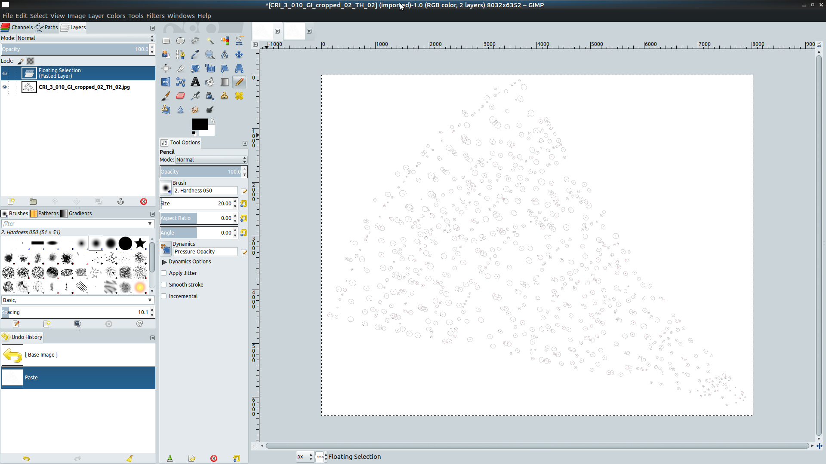

1. Right click on the layer in the layer menu (usually bottom right, should be displayed as a “floating selection”/“schwebende Auswahl” by now) and select **To new Layer**  / **Zur neuen Ebene**.

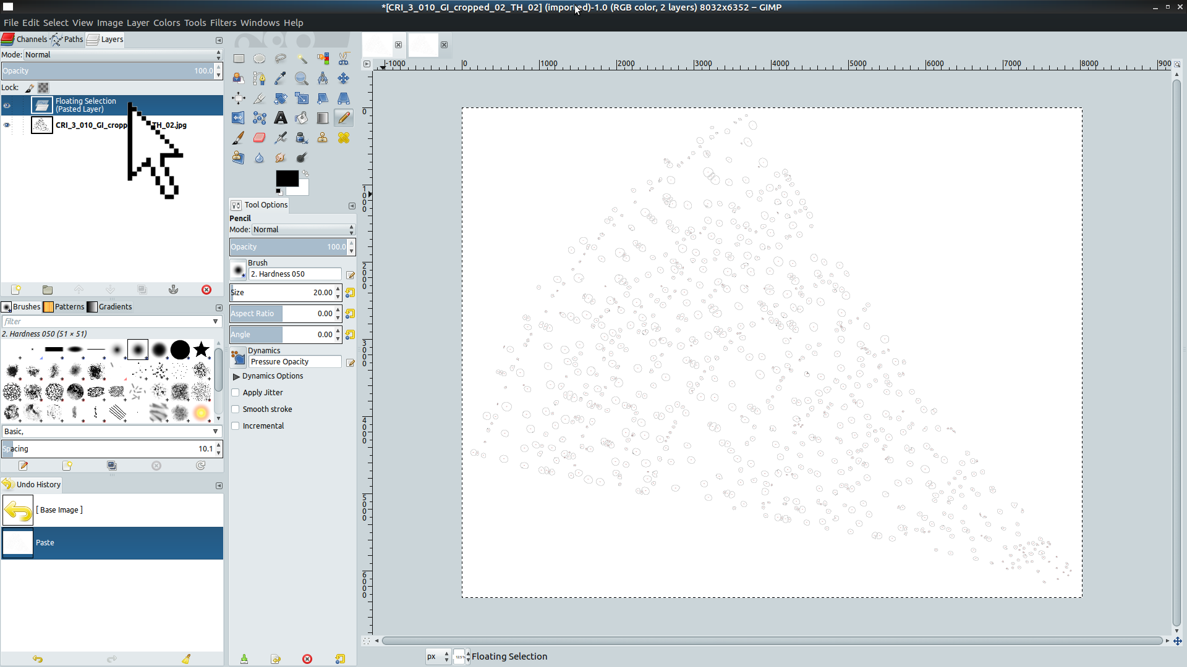

1. Choose the *Wand* tool (click in image area and press *U*) and click into the white area surrounding the outlines.

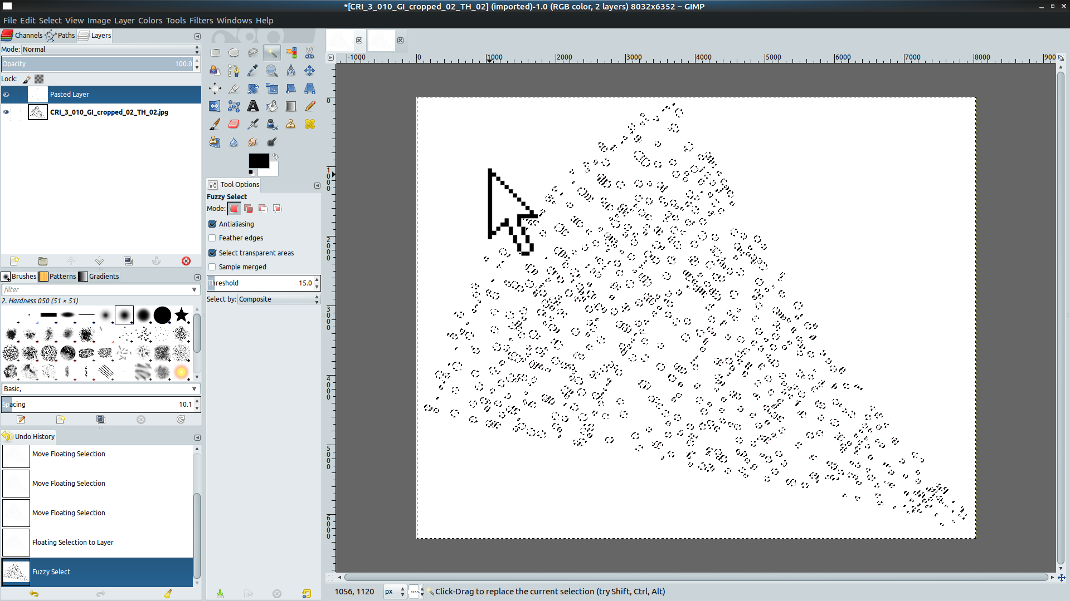

1. Cut out the white background with *STRG + X*.
2. Now the threshold image and the classification are overlaid, and it should be possible to identify places where the classification did not work.
3. Most common problems:
   * Large vessels not recognized because of their shape - solution: manual correction (see below) or lower minimum on Roundness in ImageJ’s *Analyze Particles* tool,
   * Tracheids mistakenly classified as vessels - solution: higher minimum Size or higher minimum Roundness (if tracheids have a more blocky shape) in *Analyze Particles*.

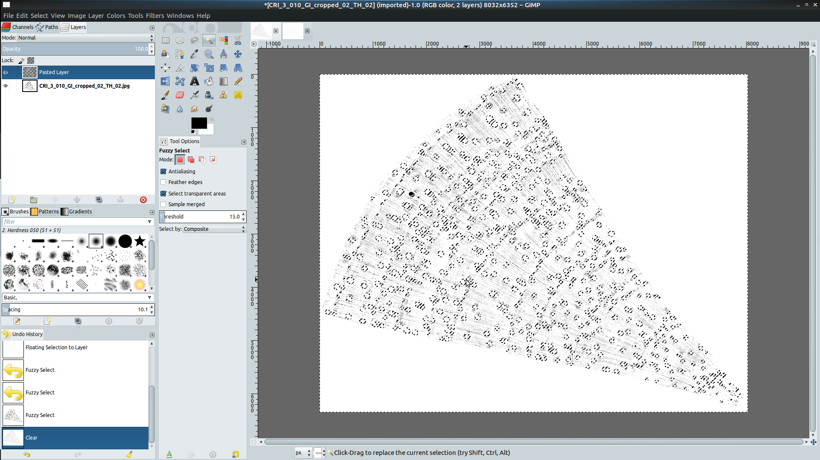

1. If there is a large number of misclassifications, go back to ImageJ and repeat the *Analyze Particles* step with different settings for Roundness and Size.
2. If there are only a few misclassified vessels: manually correct misclassifications of large vessels.
3. Make sure you choose to edit the layer with the threshold image.
4. Choose the pencil tool (shortcut: *N*) to edit the threshold image and
   * make sure the right tool options are set: Hardness and Opacity should be at 100,
   * *Alt + up/down arrow* or *Alt Gr + mouse wheel* change the pencil tool tip size,
   * *X* can be used to switch between background and foreground color (black and white).

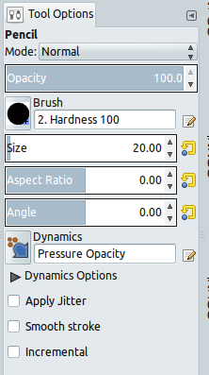

1. Zoom in to places where large vessels were misclassified and “repair” large vessels with wall damage that reduces their roundness below the classification level.

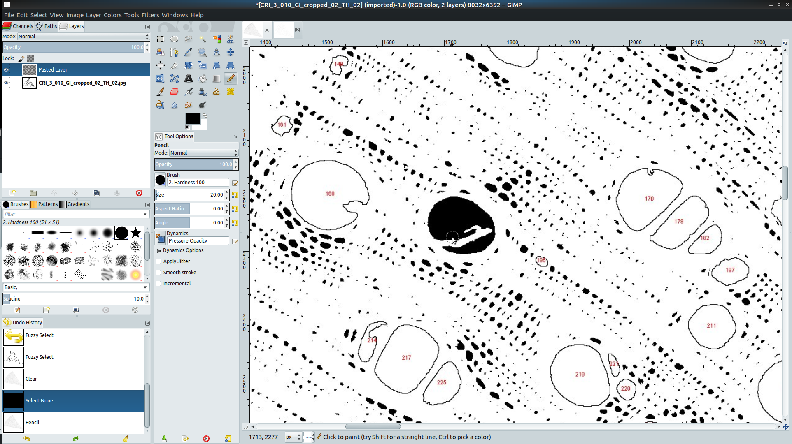

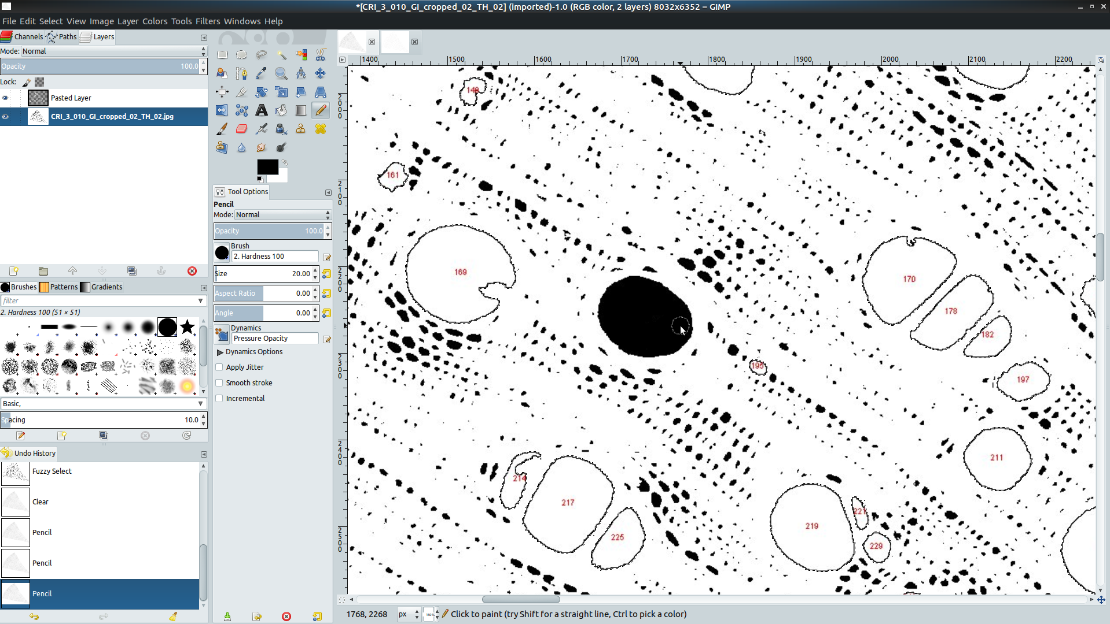

1. Use white color to remove tracheids that are erroneously classified as vessels,
   * click on the eye symbol on the left of the outline layer to show/hide them & see what you are doing (arrow!),

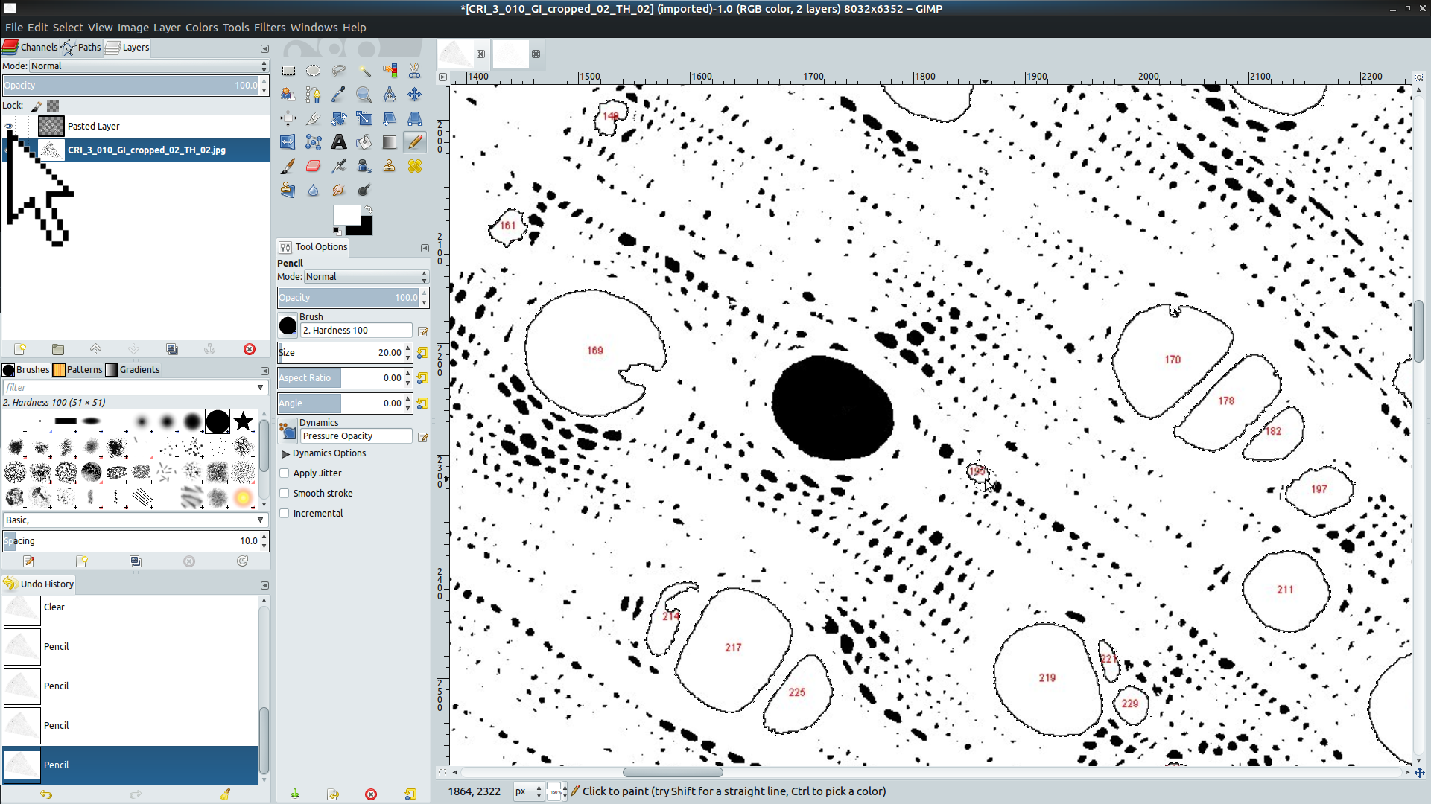

1. When you have finished editing, hide the outline layer (eye symbol!) and export the threshold layer as CODE_GI_cropped_02_TH_02_edit.jpg using the “Export as” dialog or *Strg + Shift + E*.

# Final steps

1. Now, open the image in ImageJ (drag and drop) [if no size in µm is shown on the upper left of the image window, you have to set the scale again; see above],
2. Click on **Image ➜ Type ➜ 8bit** to make sure resetting the threshold works,
3. Reset the threshold by clicking **Image ➜ Adjust ➜ Threshold**
   * The choice of the threshold value should not matter because the image is black and white,
   * In some cases it may be necessary to uncheck “Dark Background” to avoid a color swap.



1. Repeat all steps starting from the *Analyze Particles* section.
2. Save the new outlines as CODE_GI_cropped_02_TH_02_edit_Outlines_300_0,3.jpg (**File ➜ Save As** in the main window).
3. If you are happy with your classification results, save them as CODE_GI_cropped_02_TH_02_edit_Outlines_300_0,3_Results.xls (**File ➜ Save as** in the Results window). **Be careful not to have two dots (“.”) in the file name or it will not be possible to save as a .csv file! The screenshots still contain filenames with two dots because we just learned about this bug pretty recently. Please avoid this mistake!**
4. Use GIMP to copy the new outlines on top of the threshold image and cut out the background (just as in this step).
5. Save the resulting image (using the “Export as” dialog or _STRG + Shift + E__) using the name CODE_GI_cropped_02_TH_02_edit_Outlines_300_0,3_Analysis.jpg.
6. Your project folder should now look somewhat like this (note that often, you will have to try more than one setting for circularity and minimum vessels size, and you will have to do more than one edit, which all show up as additional files in the project folder):

